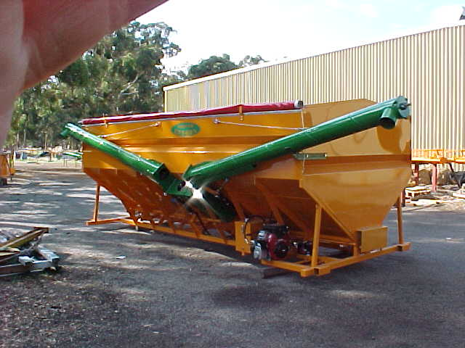
Congratulations on the purchase of your
NORRISH EZY BIN
YOUR SEED, SUPER AND FERTILISER BIN.

This bin has been designed for maximum efficiency to assist your seeding operation. With a large variation of length and combination of split bins,- two and three section bins and large 26ft bins, also available any combination of two bins.

A Norrish Ezy Bin makes your seeding operation
enjoyable , allowing you to get your crop in
the ground as fast and efficient as possible.

The totally hydraulic system allows you to have full control of the speed of the operation of the augers, as well as taking all the hard work out of the filling of combines and air seeders.

The hydraulic system is a totally enclosed system,
with the oil circulating around through all four of
hydra motors (or six if its a three-section bin).

The engine speed determines the auger speed. You adjust the engine speed to suit your own filling requirements.

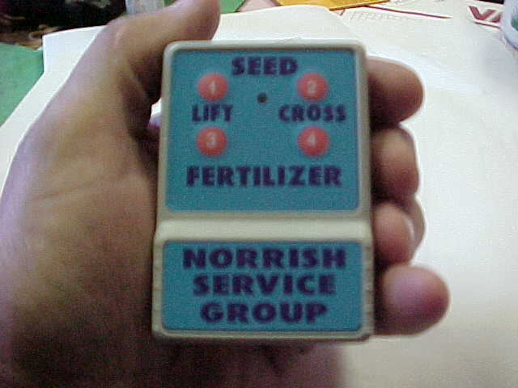

The remote system allows the operator to start and stop the lift auger and cross auger that is feeding the lift auger at any time, by pushing the remote button. This can be done up to one hundred and fifty feet away. (50 meters). This allows the farmer to check other parts of his seeding machinery while at the same time having full control of filling.

The push button system on the remote is a fail-safe system
the lift auger cannot be shut off leaving the cross auger feeding. If you wish to clean the lift auger out, shut the cross auger off first, give it five to ten seconds to empty the
lift auger, then shut the lift auger off.

If you unintentionally push the lift auger button, this will
shut off both the lift auger and the cross auger. If you
then push the lift auger button again this will start both the
lift and the cross augers up at once.

If for any reason you have to use the manual system on
top of the receiver box, the four buttons give you
control over the hydra motors.

From the back 1 Front bin discharge auger
2 Front bin floor auger
3 Rear bin discharge auger
4 Rear bin floor auger
(6 Button remote is similar)
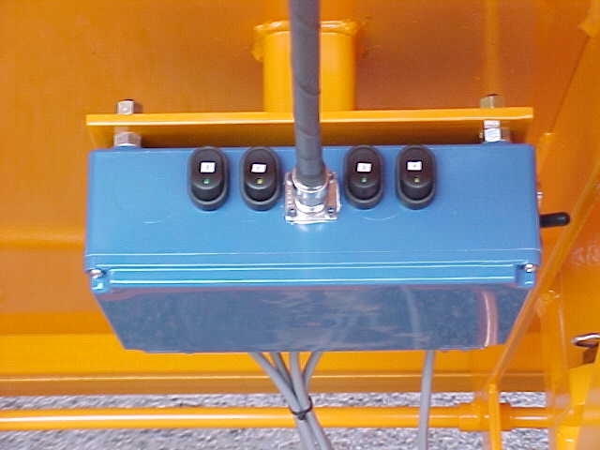

Please note:
These buttons do not have a fail-safe system

Each button turns on and off its own auger or cross lift
Auger, there is no fail safe system here, so the operator must be vigilant at all times, knowing that he must turn
the cross auger off before he shuts off the lift auger.
Note: The receiver box has a master switch.

The electric current to the master switch on the receiver
box is controlled by the start key to the Vangaard motor, preventing a flat battery. You will note when you turn
the key of the Vangaard motor on, a red light on the
receiver box shows, indicating power is on.
(The receiver box is turned on,
Only if the master switch is on.)

The augers are lined with 8 inch poly pipe, the poly pipe
has a very low friction co-efficient thus making moving of fertiliser and seed up the auger relatively easy.

The poly pipe is inexpensive to replace, it is a simple matter of undoing the two bolts and removing it from the auger. It is advisable to remove and install the poly pipe in cold conditions due to the expansion of black poly pipe on a hot day.

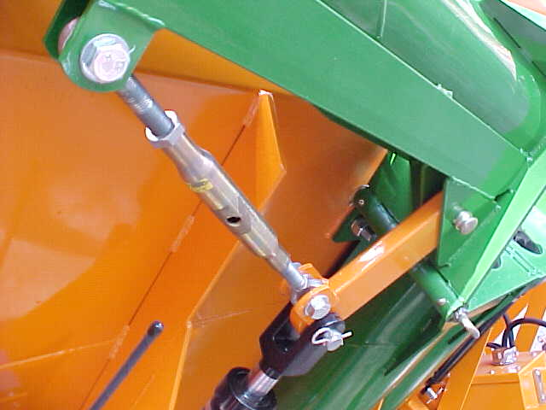

To operate the hydraulic levers to raise or lower the augers, push the lever up slightly to raise the auger, each auger has a turnbuckle adjusting system to limit the maximum travel.
When the ram is fully extended, the auger is only just closed thus preventing any damage by over tightening the auger.

To fold the auger to transport position, lower the hydraulic lever slightly. A bypass valve has been installed to prevent damage to the auger whilst lowering down.

It is best to operate the folding and unfolding of the
augers while the engine is in a low idle position thus
reducing any chance of any major damage through
having maximum power in the hydraulic system.

The bin has six inch cross auger flighting, feeding across the bottom of the bin. There is a floating auger cover to protect the six inch auger, it has been designed if necessary to weld a 10mm rod on to the auger shaft at the outer edge of the bin, which will cause the auger cover to vibrate when the cross auger is being operated. At this stage we have not found it necessary to weld the ten mm piece of steel on.

The discharge auger or lift auger has an 8-inch barrel,
running at a maximum revs of 400 revs per minute.

There are four major grease points on the bin which must be greased daily. They are:

Two grease nipples for the support bushes on top of the bottom half of the lift auger
and
Two grease nipples to the bearing on the bottom of the bottom half of the lift augers, via the grease line.

It is recommended that the hinge for the augers be greased weekly to prevent ceasing

All other bearings such as on the top of the lift augers on the outer ends of the cross augers are seasonal greasing, depending on operation.

Due to the limited use, the hydraulic oil systems filter should be changed seasonally and the oil every three years.
The hydraulic oil used is a hydraulic 46 oil
any quality farm hydraulic oil is quite adequate.

The reason we have chain drives on the cross augers,
is to allow the owner to control the speed of the cross auger,
if necessary by changing cog sizes, but from the experimental work we have done, we have found the sizes supplied are more than adequate to run the bin.
The chain requires a slight lubrication every one to two weeks as its work load for the season is relatively low.

Before any welding or jumper leading of batteries, please ensure the receiver box master switch is turned off,
as damage to the system may occur.

When connecting batteries or jumper leading the Vanguard motor please ensure that terminals are on in the correct position or the electronics of the motor will be damaged.

At all times the wire cable must support the
auger in the working position.

After a few hours work check that
all nuts and bolts are tight.

